The Pride Seesaw & Leaven of the Pharisees
November 26, 2017
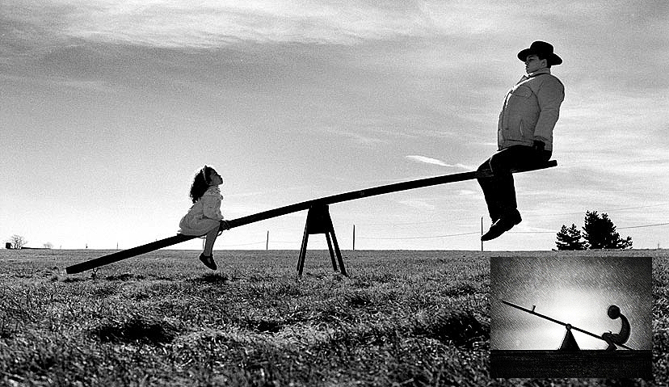
Jesus, thank you for guarding us as the apple of Your eye, and not allowing Pride to get a destructive foothold in us.

Thank You, Lord, for humbling me. I could feel that I needed it and I asked for it to be gentle, because hard falls are really miserable… And You were gentle, so very gentle—but still quite convicting. Then You held me close to your heart and looked down at me with such understanding and compassion. How wonderful is Your Merciful Heart. I wish I could sing forever about it.

Well, guys—it was one of those days. You think you’re on a roll...right? Everything I did was either frustrating or an embarrassing failure and I could just feel the Lord’s loving hand pulling me back. Although I shouldn’t be embarrassed or surprised, because I was only doing what comes naturally to me when I'm on my own.

Jesus began, “Well, My Love, My Dearest. You did ask, and it did need to be done. And I’m so glad you asked, so it could pass quickly and you could return to the firm footing of being in the last place and the least of all.

"Oh, the treasures I will impart to the soul who knows themselves as I know them. The greatest gifts, the greatest treasures for those who confess the reality of who they are, for those who have the wisdom to ask, 'show me who I am in Your eyes, Lord.' This is a wise request I will never, ever deny.

"Dear souls, you have nothing to fear in seeing who you are before Me—now, in this moment. The fear should come when you’ve been skirting the issue and fooling yourself. That should cause you great internal unrest, because you are walking on paper-thin ice. Better to be walking on the glacier of humility than skating on thin ice, full of pride, independence and self-assurance.

"Oh, My souls, when you begin to feel that independent 'I can do it!' attitude well up in you, run to My arms and beg Me to return you to reality, before I must allow a serious fall. Do this always with Me and I will show you your faults and grant you tears of repentance, forgiving you always. Yes, always. I am so full of forgiveness and a fresh start for you."

I asked the Lord, "Well, I understand this, Lord. But then there are times where I need to confess, “I CAN do this.”

Jesus replied, "You are missing the rest of the sentence, Clare: 'through Christ, Who strengthens me.'”

Oh. I usually do say it this way… But I felt something different I didn’t like at all.

Jesus continued, "Yes, the Independent spirit. You can say the right words, but have the wrong attitude. It’s when you get the bit in your teeth and start running with it, ignoring all the warning signs, 'Danger ahead, bridge out.'"

Jesus, I could feel this, and I didn’t like it at all—the leaven of the Pharisees. That’s why I asked, "Please help me. I feel pride and independence welling up in me and it feels awful." But, please be gentle? Help me out of this sin.

And my husband pulled a rhema card for me last night. Gosh, that rhema card file—it's a shoebox that must be 20 years old. Anyway, he pulled a card and he left it where I would see it as I got into bed, so we didn’t have to talk about it.

It said something like this—I couldn't find it to give you the exact words—but it said something like this, “The spirit of learning, acquiring knowledge and independence.” That's all it said... And when I saw it, I felt quite badly and a little resentful, so pulled another card from the same old ancient shoe box, asking the Lord, “Please, say something nice to me.” And the card I pulled said, “I am for you, not against you.” And I knew immediately the Lord was pointing out my sin and wanting to help me, not to condemn me. Oh, my husband is SO brave!

Dear ones, it is easy to be so zealous that you fall into pride: “I’m ploughing ahead and I’m not letting anyone hold me back or stop me. I’M doing this. And I'm showing you how to do it, too, by the way!”

It’s the Pride seesaw going too far up the other way. What I mean by that, is that when you feel lousy about yourself, very often hand fed by the demons: ”Oh, you are such a failure.” you have the Uglies, and are at the bottom of the seesaw. Then, when you get up the courage to think you can overcome yourself… Well, beware that you don’t go too far and put on an Independent spirit attitude, rising from the ground too high up in the air on the seesaw. It’s that high feeling that is my demise.

The right way to do this is to come to the Lord and ask Him to put you back up on your feet, which He will always do, but I have the fault of being too strident in my participation with that and then I can fall into Pride. Oh, how I hate that word!

Now I can truly feel what Paul meant when he said, ”What a wretched man I am! Who will rescue me from this body of death?” That's Romans 7: 24

Jesus answered me immediately, "Clare, I will always rescue you from this 'body of death'. Always. Because I want you to be free. And when you are walking tall, you are in bondage—because you truly cannot see where you are headed, and you can’t read the warning signs either, 'Danger, bridge is out ahead!' And just as I came to Paul’s rescue, I will come to yours, as well.

"My People, there is nothing more dangerous than an independent, prideful attitude. Mostly because it is when you are laying the foundations of a work that you can be filled with this leaven, and it becomes imbedded in the foundation. This will affect everyone you minister to and you will be just another minister pushing Pride—which is what destroys the Body and makes churches void of My Spirit.

"It is when you open that sack of cement in fear and trembling, and begin to mix it with the Living Waters flowing from within. The Source is ME—that you have a sound foundation that will beget holiness in those you minister to. Those of you, My dear ones, who have felt so tied down by your failures in the past, be very, very, careful of this contamination as I am raising you up. If it is all about Me doing the doing, you are safe. But if for one moment you raise your head up high, running with the bit in your mouth, everything you do from that place will be subject to failure when you get your wits about you."

Yeah, that's another reason I want to mention about painting and drawing. People keep telling me I have talent. I know. I know that I know that I know: I DO NOT have talent! It's the LORD doing it THROUGH me. And I insist on that, because I don't want people to get the idea that, 'Wow! Talent!' You know—some kind of goddess. That's ridiculous!

And it's the same thing you'll take on yourself if I model that for you. So, I'm trying to get you to understand: I DON'T have talent. And it's very dangerous to think that you're talented. Because everything that comes out of me comes from the Lord. I know what I can do with a pencil and piece of paper on my own, and believe me, it is NOT pretty! I know that when I pray and I allow the Lord to work through me that something beautiful will come out of it, even though He's 'writing with a broken pencil.'

So, this is a secret: you don't have to run around telling people, 'oh, look at this. Isn't this wonderful! Didn't I do a great job.' with pats on the back. No, no, no. If you've got that kind of a spirit, you'd better not be doing anything. Because you're sure to stumble and fall. And fail. And embarrass people. And worst of all, show people how to be proud. That's not what we need, guys. We need to understand that it comes from the Lord, and He gets ALL the glory for it. We don't get the glory.

So, I'm saying that, because there are a few people who are being raised up in art right now. And it's very important for them to understand, that if they're basing their self-worth on some kind of talent, they're in danger. Because the self-worth comes from Jesus dying on the Cross for us. There's nothing more valuable than that, and that's where our worth comes from.

And the rest is a Gift! It's just simply a gift. It can be given and it can be taken. It's a gift. So, beware, my dear ones.

And so, to continue with what the Lord was saying.

"So, what am I saying?" He continues. "Be encouraged, because We can do this together. I have called you forth. You are walking in fear and trembling, because you see what I am calling you to and it’s more than you can deal with. You know this, deep down in your heart.

"Good. Now you know Who is at the helm and who is in the engine room—and there’s no danger of you turning this into YOUR gift. Your ministry. Your talent. It is Mine from beginning to end. All Mine. Conceived by Me, supplied and empowered by Me. And you are merely managing the resources and doing your part as My emissary. Oh, please—stay in this state of mind and the fiery darts of Pride shot from the bows of the enemies will find no fuel in you to continue burning. The Living Waters will quench the arrows and they will immediately go out"

Now this is really interesting. I just got a card...well, actually it is a rhema from the website: "Where there is no wood, the fire goes out." And I thought, 'What does this have to do with? I can't imagine what this has to do with??' Well, now I know what it has to do with it. The wood is Pride. So, the fiery darts hit that and they just explode with flames of Pride.

So, the Lord continued, "This truly is the secret of a Godly ministry. We are doing this together, and you are My humble servant. Protect this truth with all your might, because Satan will not fail to try and embed Pride in your heart. If you are aware and expect it, you will be vigilant to protect it."

